**Operating Systems**

**Practical**

Name: Kuldeep Saini

Roll No: 20201415

University roll no – 20020570017

SUBMITTED TO – Mr. Nikhil Rajput

Course: B.Sc. (Hons) Computer Science

**Set - 1**

1. **Implement SJF with specified arrival time and burst time. Compute waiting time, turnaround and completion time.**

**Description: -**

Shortest job first (SJF) or shortest job next, is a scheduling policy that selects the waiting process with the smallest execution time to execute next. SJN is a non-preemptive algorithm.

1. Start Time (ST), Completion Time (CT), Turnaround Time (TAT) and Waiting Time (WT) for each process.
2. Average turnaround Time and Waiting Time

**P-** Processes

**AT-** Arrival Time

**BT-** Burst Time

**ST-** Start Time (Current Time)

**CT-** Completion Time

**TAT-** Turnaround Time

**WT-** Waiting Time

Firstly, we sort all the process according to the arrival time. Then select that process which has minimum arrival time and minimum Burst time. After completion of process make a pool of process which after till the completion of previous process and select that process among the pool which is having minimum Burst time and then we can find TAT, WT and CT with

Formulas.

1. TAT = CT- AT
2. WT = TAT – BT
3. CT = ST + BT

Gantt chart: -

|  |  |  |  |  |
| --- | --- | --- | --- | --- |
| P1 | P2 | Ideal | P3 | P4 |

0 2 4 5 8 12

**Output: -**

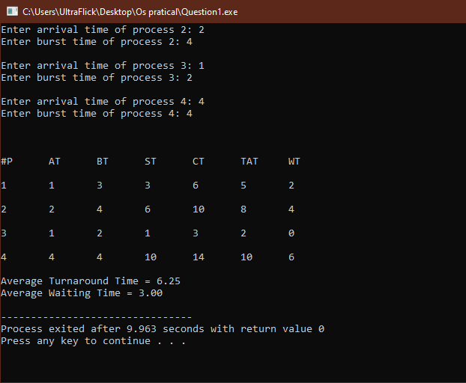

**2.** **Implement SJF with specified arrival time and burst time. Compute waiting time, turnaround and completion time.**

**Output: -**

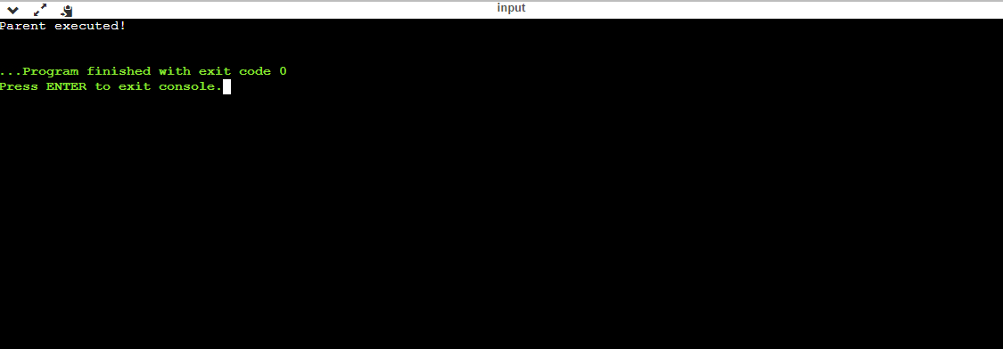

**Description: -**

In the code, a child process is created. fork() returns 0 in the child process and else all the values in the parent process.

Here, only one outputs is possible because the parent process get executed first. So we know that the OS will first give control to the parent process and not to the child process.

Parent process and child process are running the different program. OS allocate different data and states for these two processes, and the control flow of these processes can be different.